CO5_ASSESSMENTS 2
PSEUDOCODE WRITING TASK
1. Real-Time Face Detection and Recognition
A security system must process a live camera stream to:
- Capture video frames continuously.
- Detect multiple faces.
- Recognize registered persons using a trained dataset.
- Display bounding boxes and identity labels.
Constraints:
- Must operate in real time.
- Processing delay should be minimized.
- Multiple faces must be handled simultaneously.
Write detailed pseudocode for the complete OpenCV-based face detection and recognition pipeline. Include image acquisition, preprocessing, face detection, feature extraction, recognition, visualization, and efficient loop control.

2. Vehicle Detection, Tracking and Counting
A traffic monitoring system must analyze a live video stream to:
- Detect vehicles entering a predefined region of interest.
- Track multiple vehicles across consecutive frames.
- Count vehicles crossing a virtual line.
- Display bounding boxes, tracking IDs, and vehicle count.
Constraints:
- Avoid double counting.
- Handle multiple vehicles simultaneously.
- Maintain near real-time performance.
Write detailed pseudocode for the complete OpenCV-based vehicle detection, tracking, and counting system. Include video acquisition, preprocessing, detection, tracking, counting logic, visualization, and efficient loop termination.

1. Real-Time Face Detection and Recognition

ALGORITHM: REAL_TIME_FACE_DETECTION_AND_RECOGNITION

BEGIN

Initialize camera
Load face detection model
Load trained face recognition model
Load registered names and facial features

Set DETECTION_THRESHOLD
Set RECOGNITION_THRESHOLD
Set FRAME_SKIP
frame_count ← 0

IF camera is not opened THEN
PRINT "Camera Error"
STOP
END IF

WHILE TRUE DO

frame ← Read frame from camera

IF frame is empty THEN
BREAK
END IF

frame_count ← frame_count + 1

Resize frame

IF frame_count MOD FRAME_SKIP ≠ 0 THEN
Display frame
IF key pressed = 'q' OR ESC THEN
BREAK
END IF
CONTINUE
END IF

gray_frame ← Convert frame to grayscale
gray_frame ← Apply Gaussian Blur(gray_frame)

IF lighting is poor THEN
gray_frame ← Apply Histogram Equalization(gray_frame)
END IF

faces ← Detect Faces(gray_frame)

FOR each face IN faces DO

confidence ← Get detection confidence

IF confidence < DETECTION_THRESHOLD THEN
CONTINUE
END IF

face_image ← Crop face from frame
face_image ← Align face
face_image ← Resize face
face_image ← Normalize face

features ← Extract Facial Features(face_image)

best_match ← Compare features
with registered features

similarity ← Get similarity score

IF similarity >= RECOGNITION_THRESHOLD THEN
identity ← best_match
ELSE
identity ← "UNKNOWN"
END IF

Draw bounding box around face
Display identity on frame

END FOR

Display processed frame

key ← Get keyboard input

IF key = 'q' OR key = ESC THEN
BREAK
END IF

END WHILE

Release camera
Destroy all windows

END

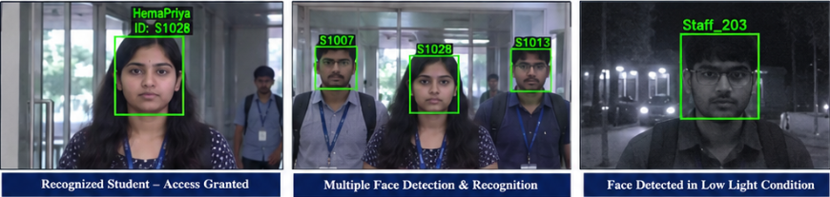

2. Vehicle Detection, Tracking and Counting

ALGORITHM: VEHICLE_DETECTION_TRACKING_AND_COUNTING

BEGIN

Initialize video source

Load vehicle detection model
Initialize vehicle tracking method

Define Region Of Interest (ROI)
Define virtual counting line

vehicle_count ← 0
next_vehicle_ID ← 1

TRACKS ← Empty List
COUNTED_IDS ← Empty Set

Set DETECTION_THRESHOLD

IF video source is not opened THEN
PRINT "Video Source Error"
STOP
END IF

WHILE TRUE DO

frame ← Read frame

IF frame is empty THEN
BREAK
END IF

Resize frame

frame ← Apply Gaussian Blur(frame)

roi ← Extract ROI from frame

detections ← Detect Vehicles(roi)

FOR each detection IN detections DO

confidence ← Get confidence
class ← Get object class

IF confidence < DETECTION_THRESHOLD THEN
CONTINUE
END IF

IF class is NOT
car AND
class is NOT bus AND
class is NOT truck AND
class is NOT motorcycle THEN
CONTINUE
END IF

x, y, width, height ← Get Bounding Box

centroid_x ← x + width / 2
centroid_y ← y + height / 2

Store detection

END FOR

FOR each detection DO

matching_track ← Find nearest existing track

IF matching_track exists THEN

vehicle_ID ← matching_track.ID

previous_position ← matching_track.position
current_position ← detection.centroid

Update matching_track

ELSE

vehicle_ID ← next_vehicle_ID
next_vehicle_ID ← next_vehicle_ID + 1

Create new track

previous_position ← NULL
current_position ← detection.centroid

END IF

END FOR

FOR each active track DO

IF vehicle crosses virtual counting line THEN

IF vehicle_ID NOT IN COUNTED_IDS THEN

vehicle_count ← vehicle_count + 1

Add vehicle_ID
to COUNTED_IDS

END IF

END IF

END FOR

FOR each track DO

IF vehicle is missing
for maximum allowed frames THEN

Remove track

END IF

END FOR

Draw ROI
Draw virtual counting line

FOR each active vehicle DO

Draw bounding box
Display vehicle ID
Display vehicle class

END FOR

Display "Vehicle Count = ", vehicle_count

Show frame

key ← Get keyboard input

IF key = 'q' OR key = ESC THEN
BREAK
END IF

END WHILE

Release video source
Destroy all windows

END
